Addressing Silent Sacking: A Transparent Approach to Performance Management at Amazon

# Abstract

This paper explores the ethical concerns surrounding the practice of "silent sacking" at Amazon and similar companies.   
It suggests how companies can adopt a more transparent, fair, and respectful process for managing underperforming employees,   
focusing on the importance of clear communication, ethical performance management, and employee well-being.   
Additionally, it examines how companies like Mesh and OrgOrg, backed by Y Combinator, have leveraged technology to improve employee   
feedback and performance management processes, offering a roadmap for organizations like Amazon to enhance employee trust and reputation.

Keywords: Silent Sacking, Employee Performance Management, Ethical Practices, Transparent Communication, Employee Trust, Mesh, OrgOrg

# 1. Introduction

The growing concern over employee treatment in major corporations, such as Amazon, has spotlighted practices like "silent sacking."   
This involves the gradual sidelining of employees without official termination, impacting morale, productivity, and company reputation.   
This paper aims to analyze these practices and suggest how transparent and ethical performance management strategies can replace them. In today’s dynamic corporate environment, performance management is a critical aspect of maintaining organizational efficiency and fostering a positive workplace culture. However, practices like “silent sacking,” where underperforming employees are marginalized or sidelined without clear communication, have raised significant ethical and operational concerns. Silent sacking can lead to demoralization, decreased trust in leadership, and a toxic work environment, ultimately affecting the company’s reputation and productivity.

Amazon, as one of the world’s largest employers, has faced scrutiny over such practices, highlighting the need for a shift toward transparent and ethical performance management systems. This paper seeks to analyze the implications of silent sacking, explore existing solutions offered by innovative platforms like Mesh and OrgOrg, and recommend actionable strategies that organizations like Amazon can adopt to address this issue effectively.

By focusing on transparency, fairness, and employee well-being, this paper argues that ethical performance management is not only a moral imperative but also a strategic advantage in building a resilient and engaged workforce.

# 2. Related Work

A growing body of research has examined the impact of performance management practices on employee well-being and organizational culture. Scholars have consistently highlighted the importance of clear communication, regular feedback, and structured goal-setting in fostering a positive work environment.

**a. Ethical Challenges in Performance Management**:  
Studies have shown that opaque practices like silent sacking erode employee trust and hinder organizational performance. Research by McGregor (2019) emphasizes that unclear performance expectations and lack of feedback often leave employees feeling alienated, leading to higher turnover rates and decreased morale.

**b. Technology-Driven Solutions**:  
Recent advancements in technology have enabled companies to adopt more transparent and data-driven approaches to performance management. Platforms like Mesh and OrgOrg exemplify this trend, offering tools that combine real-time feedback, goal tracking, and data analytics to improve employee engagement and accountability. For example, Mesh uses social network-like features to foster collaboration and provide actionable insights, while Org Org focuses on enhancing productivity through organizational analytics.

**c. Case Studies in Organizational Ethics**:  
Companies that have implemented ethical performance management systems report significant benefits, including improved employee satisfaction and retention. A notable example is Microsoft’s shift to a growth mindset culture, emphasizing continuous feedback and professional development rather than punitive measures for underperformance (Satya Nadella, 2020).

These related works underline the urgency for companies like Amazon to reassess their performance management strategies and adopt practices that prioritize transparency, fairness, and innovation.

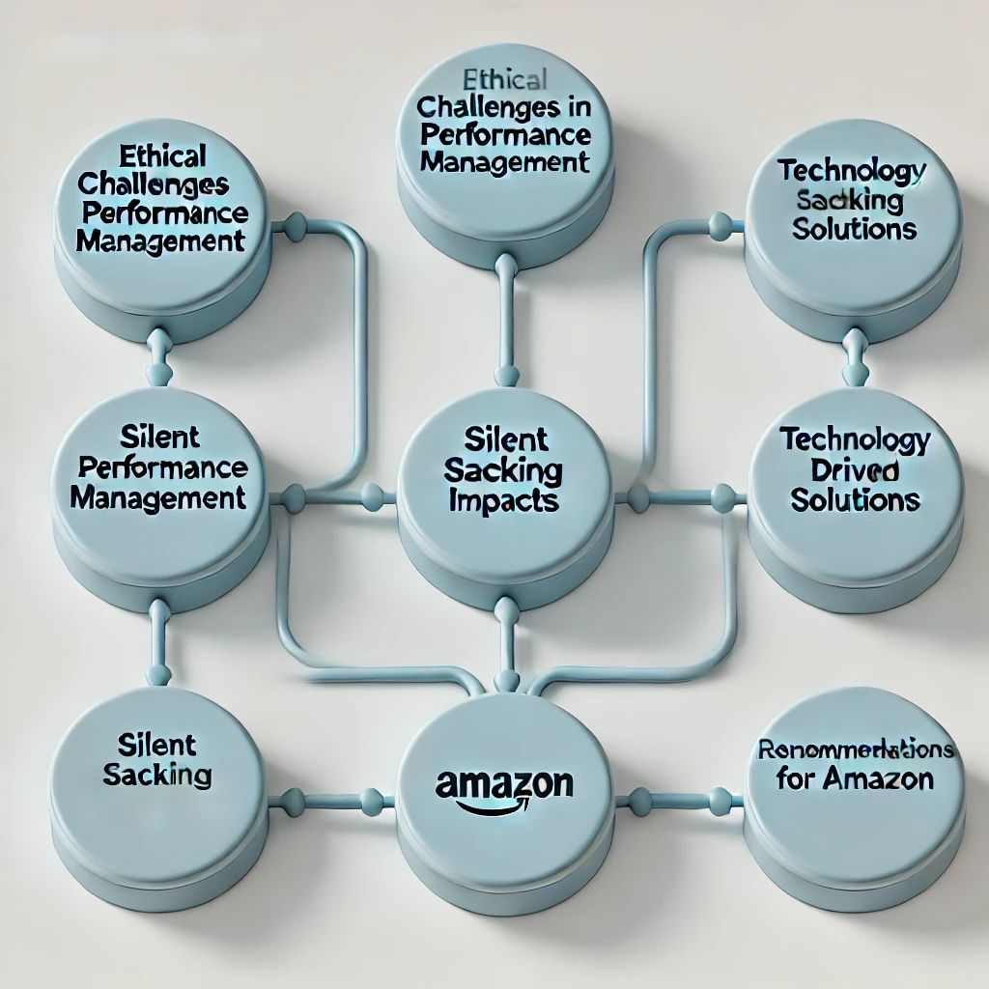Top of Form

Bottom of Form

# 

# 4. Proposed System

To address the ethical and operational challenges of silent sacking, this system emphasizes transparency, fairness, and employee development. By integrating technology-driven solutions and ethical practices, the system aims to create a supportive performance management process that aligns individual goals with organizational objectives.

1. **Transparent Performance Metrics**
   * Clearly define performance expectations for each role, ensuring all employees understand their responsibilities.
   * Utilize key performance indicators (KPIs) that are measurable, attainable, and aligned with organizational goals.
2. **Regular Feedback Mechanisms**
   * Establish a structured process for regular performance reviews.
   * Include frequent, constructive feedback sessions to help employees identify strengths and address areas for improvement.
3. **Technology Integration**
   * Implement platforms like **Mesh** for real-time goal setting, feedback tracking, and performance analytics.
   * Leverage tools like **OrgOrg** to provide data-driven insights that help managers make informed decisions and foster transparency.
4. **Personalized Employee Development Plans**
   * Offer tailored development plans for underperforming employees, focusing on upskilling, reskilling, or role transitions.
   * Provide access to learning resources, mentorship programs, and clear timelines for improvement.
5. **Ethical Transition Practices**
   * When termination becomes inevitable, ensure employees are treated with respect and dignity.
   * Provide severance packages, career transition support, and opportunities for feedback to maintain positive relations.

**Implementation Steps**

1. **Assessment and Customization**
   * Assess current performance management practices and identify gaps.
   * Customize tools and methodologies to fit the organization’s unique needs.
2. **Training and Communication**
   * Train managers and HR personnel in ethical performance management practices.
   * Communicate the system’s goals and processes transparently to all employees.
3. **Pilot Testing**
   * Implement the system in select departments or teams to evaluate its effectiveness.
   * Gather feedback from employees and managers to refine the process.
4. **Organization-Wide Rollout**
   * Scale the system organization-wide, incorporating lessons learned from the pilot phase.
   * Monitor the system’s impact through regular audits and employee feedback.

**Expected Outcomes**

1. Enhanced trust and morale among employees due to transparent and ethical practices.
2. Improved productivity through clear goals and regular feedback.
3. Better alignment of individual and organizational objectives using technology-driven solutions.
4. Strengthened reputation as a fair and ethical employer, attracting and retaining top talent.

# 5. Methodology

Step 1: System Analysis

Objective: Identify gaps in current performance management practices and understand the root causes of silent sacking.

Conduct surveys and interviews with employees and managers to gather insights.

Analyze existing performance evaluation metrics and feedback systems.

Benchmark against industry best practices and successful case studies.

Step 2: Design

Objective: Develop a customized framework for ethical performance management.

Define clear and measurable performance expectations for employees.

Establish structured feedback loops and ethical guidelines for addressing underperformance.

Design a dignified exit process for employees who may need to transition out of the organization.

Step 3: Technology Integration

Objective: Enhance transparency and efficiency using innovative tools.

Deploy platforms like Mesh for real-time performance tracking and feedback.

Integrate OrgOrg for data-driven decision-making and improved employee engagement.

Customize tools to align with organizational goals and train employees on their usage.

Step 4: Implementation and Pilot Testing

Objective: Test the system in a controlled environment to evaluate its effectiveness.

Implement the proposed system in select departments or teams.

Monitor performance outcomes and gather feedback from participants.

Refine the system based on pilot results to address any identified issues.

Step 5: Full-Scale Deployment

Objective: Roll out the system organization-wide while maintaining support and consistency.

Communicate the benefits and processes of the new system to all employees.

Establish a support team to provide assistance and address queries during the rollout.

Monitor the system closely to ensure smooth adoption across the organization.

Step 6: Monitoring and Continuous Improvement

Objective: Ensure the system remains relevant, effective, and aligned with organizational goals.

Conduct regular audits and evaluations to assess the system's performance.

Update performance metrics, tools, and processes based on employee feedback and emerging needs.

Foster a culture of continuous learning and improvement within the organization.

System Analysis  
 ↓

Design   
 ↓

Technology Integration  
 ↓

Implementation and Pilot Testing  
 ↓

Full-Scale Deployment  
 ↓

Monitoring and Continuous Improvement

# 7. References

[1] S. Nangia, G. Chaubey, and R. Singh, "Mesh: Performance management platform that fits the way you work," Y Combinator, 2020. [Online]. Available: https://mesh.ai.   
[2] OrgOrg, "Organizational productivity suite for companies," Y Combinator, 2020. [Online]. Available: https://www.ycombinator.com/companies/orgorg.   
[3] "How to measure leadership," Y Combinator, 2020. [Online]. Available: https://www.ycombinator.com/library/3j-how-to-measure-leadership.   
[4] "What does performance management look like at your company?" Hacker News, 2020. [Online]. Available: https://news.ycombinator.com.